  Belize Telemedia Limited  MID_GAMIFICATION  04-Mar-2024 | Abstract  Installation Guide for MID_GAMIFICATION  Johann Hoare  VERSION 1.0

Introduction
This document provides an overview of the installation procedure for the MID_GAMIFICATION package on Oracle and Microsoft IIS for use on the production environment . After successful installation of the MID_ GAMIFICATION package , API calls between Digi and its partners to offer account payment services will be active. It ensures that the required commands are obtained to facilitate service query, update, and reversal for its customers. These APIs encompass all actions required to ensure the management of the customer account process from Digi’s Billing system.

Version History

Date | Version | Drafted by | Summary of changes | Revised by
1.0 | Johann J. Hoare | 04-Mar-24 | Document creation | Kristian Perez
1.1 | Johann J. Hoare | 04-Apr-24 | Update to Top up addition

Disclaimer
The contents of this document can only be derived rights against Belize Telemedia Limited if they are supported by duly signed documents. The information may be confidential and only for use by the addressee (s). If you have this document unjustly in your possession, you are requested to destroy it. It is not allowed to revise this document or parts thereof, copying or use outside of its context.

Contents
1 Introduction 2
2 Version History 2
3 Disclaimer 2
4 General Information 4
4.1 Overview 4
4.2 Acronyms and Abbreviations 4
4.3 Subject Matter Experts Agreement List 5
5 Access 6
5.1 Oracle Database 6
5.2 Application Servers 6
5.3 Access Credentials 6
6 Installation 6
6.1 Installation Guidelines 6
6.2 Uninstalling MID_GAMIFICATION functions – Database 7
6.3 Installing MID_GAMIFICATION functions - Database 7
6.4 Installing MID_GAMIFICATION functions - Frontend 8

General Information

Overview
As Digi continues its initiative to expand its current product and service offering, there is continued development into different areas, products, and solutions. As such, the onboarding of different content offerings has become a vital strategic initiative for the organization. This initiative has led to the development of this API guide, which serves to ensure new content solutions are easily onboarded using the information contained within this document.

Acronyms and Abbreviations

API | Application Programming Interface
REST | Representational State Transfer
SME | Subject Matter Expert
SOAP | Simple Object Access Protocol
WSDL | Web Service Description Language
URL | Uniform Resource Locator
IIS | Internet Information Service
GL | General Ledger

Subject Matter Experts Agreement List
This section lists all key personnel involved in the technical expertise listing. It will ensure that all mandatory reviewers have reviewed and agree to the contents contained herein this document. 5016298662

Name | Organization | Email | Phone Number
Zane Gibson | Belize Telemedia Limited | zgibson @livedigi.com | 501-610-0850
Kristian Perez | Belize Telemedia Limited | kperez@livedigi.com | 501-629-8662
Aaron Stevens | Belize Telemedia Limited | astevens@livedigi.com | 501-615-2299
Johann Hoare | Belize Telemedia Limited | jhoare@livedigi.com | 501-615-5644

Access
Authorization is required to access all of the following systems. .

Oracle Database
Server: 172.21.52.55
Port: 1521
Service Name: mdlwprd
Username/Password: Contact Database Administrator

Application Servers
SERVER | SERVER_NAME | USERNAME | PASSWORD | DESCRIPTION
172.21.52.57 | 30FE0APP02 | AD | AD | Middleware Prod Belmopan Application
10.50.52.30 | 20FE0APP02 | AD | AD | Middleware Prod Belize Application
NOTE: these servers uses BTL’s active directory to access. Contact BTL Administrator for access.

Access Credentials

Contact Security group to get access to the systems through active directory
Contact Database Administrator for access to database systems.

Installation

Installation Guidelines
This package includes a dependency on the PCK_MIND and PCK_MID package(s). The function (s):
PCK_MIND.GV_SOAP_WSDL variable must be defined in PCK_MIND before installation can occur. All Middleware APIs require PCK_MID to function. Currently there is no update to be made for PCK_MID. Installing and removing the MID_GAMIFICATION package will not affect any of the existing APIs.
After installation the below urls will be active and public facing:
Soap endpoint: https://mid.belizetelemedia.net:8443/MID_GAMIFICATION/SoapAPI.asmx?wsdl
REST Home Page: https://mid.belizetelemedia.net:8443/MID_ GAMIFICATION/

Uninstalling MID_GAMIFICATION functions – Database
To uninstall the MID_GAMIFICATION package from the database you must log on as administrator to the oracle database(5.1 above) and drop PCK_GAMIFICATION package.

Installing MID_GAMIFICATION functions - Database
Install MID_GAMIFICATION functions by downloading the ZIP file from the Appplication download page (http://gitlab.belizetelemedia.net/SoftwareDevelopment/middleware/mid_GAMIFICATION).
To install :
- Unzip downloaded zip file:
Note:
You should keep the directory tree where you unzip the files short and not under directories that contain spaces. For example, within C:\Windows unzip to C:\TEMP.
- Change your working directory to the folder with the zip file.
- Unzip file to location
- Open @1_CONFIGURE_IN_MIDDLEWARE.sql
        - Execute pl/sql block to add MID_GAMIFICATION as a system into the middleware Lines 20 -46).
        - Execute pl/sql block to add the MID_GAMIFICATION interfaces in the middleware (Lines 49-88).
        - Execute pl/sql block to add the MID_GAMIFICATION organization in the middleware (Lines 92-110).
        - Update password field on line 118 with “{update this field ADDPASSWORD}” and Execute pl/sql block to add the MID_GAMIFICATION user in the middleware(Lines 115-137).
        - Execute each:
          - Line 141 to create GAMIFICATION_SERVICE_PROVIDER table
          - Line 143 to create GAMIFICATION_SERVICE_PROVIDER_PROFILE table
          - Line 145 to create GAMIFICATION_TRANS table
          - Line 147 to create GAMIFICATION_PRODUCT_TRANS table
          - Line 148 to commit all table creations
        - Execute sql line to create GAMIFICATION_TRANS_ID sequence at Line 151.

- Open @2_Create_PCK_GAMIFICATION.sql
  - Execute pl/sql block to add PCK_GAMIFICATION head (Lines 2 - 72).
    - Update user password to password created in section 7.2 Password: *tobedeterminded* (note an error will occur if the password is not changed)
  - Execute pl/sql block to add PCK_GAMIFICATION body (Lines 76-1452).

Installing MID_GAMIFICATION functions - Frontend
Install MID_GAMIFICATION functions by logging in to each application server 5.2 above
To install :
- Log Into server 30FE0APP02.
- Go to \\30fe1app06\MID_TRANSFER
- Copy folder MID_DISTRIBUTOR to C:\middleware
- Log into server 20FE0APP02
- Repeat steps 2 - 3
- Log into server 30FE0APP02
- Open IIS application
- expand sites -> expand 171.21.52.57 -> right click on MID_DISTRIBUTOR and select Convert to Application
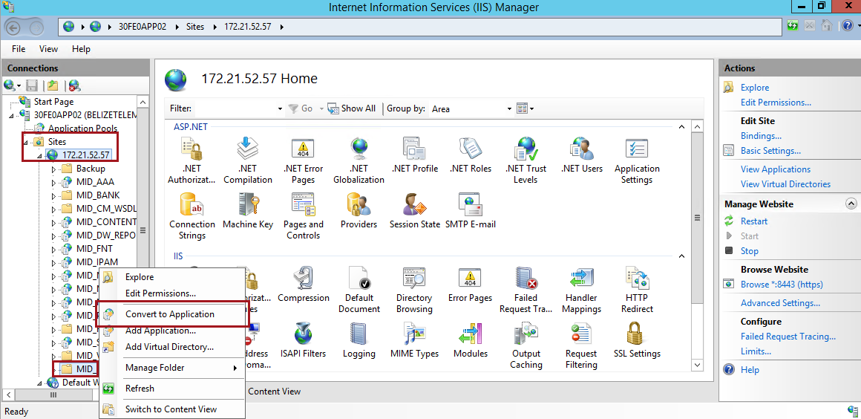
  - 30FE0APP02: 10.50.52.30
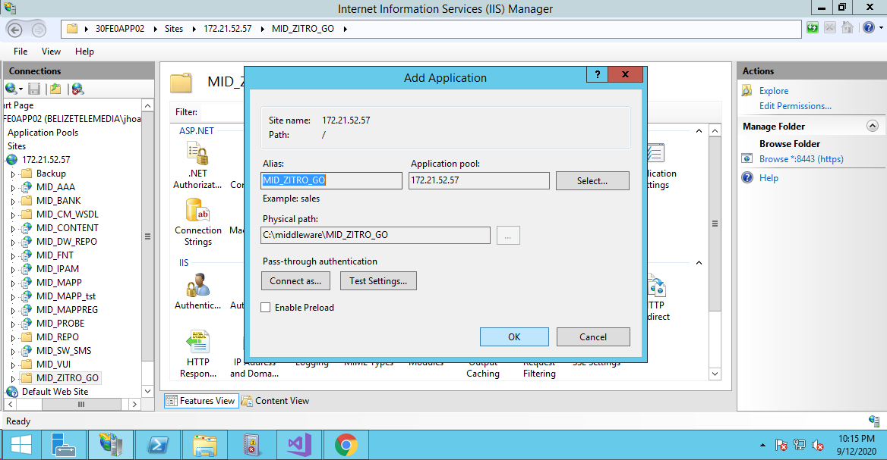
- Click on ok

- Under the MID_DISTRIBUTOR application go to the Machine Key Section. Click on generate keys and then apply.
  - Verify Verification method: SHA1
  - Verify Encryption method: Auto
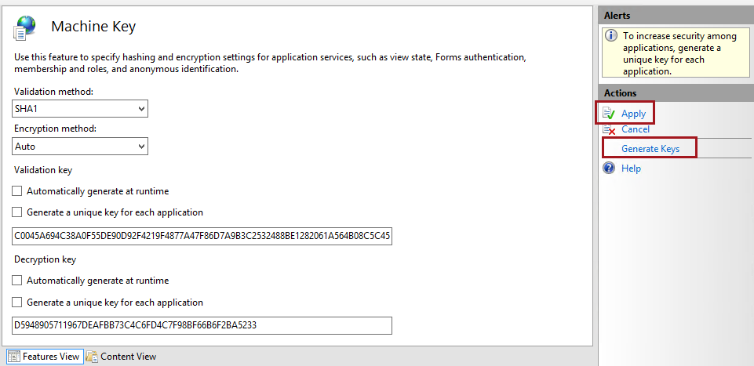
  - Uncheck all check boxes
- Copy both keys
  - Validation Key:
  - Decryption Key:
- Log into server 20FE0APP02 and repeat steps 15 -17
- Under the MID_DISTRIBUTOR application go to the Machine Key Section
  - uncheck selections if checked
  - replace the validation key with the one copied from 30FE0APP02 above
  - replace the decryption key with the one copied from 30FE0APP02 above
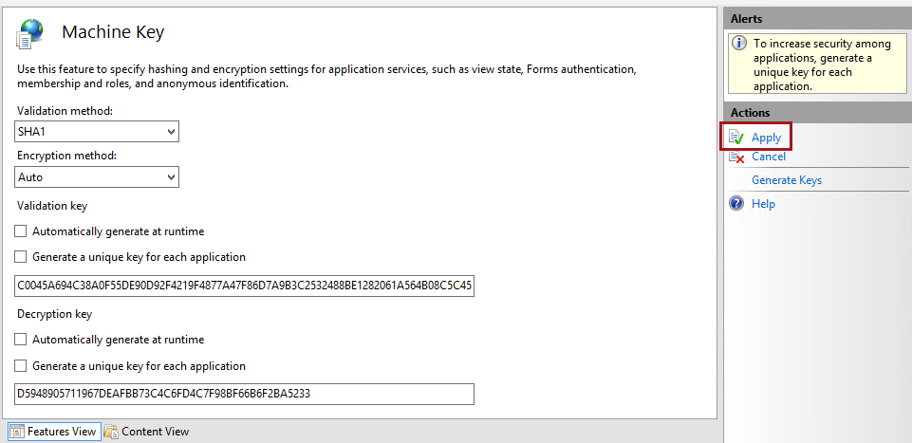
  - click on apply
Note:
Once installation is complete you can verify functionality by reviewing MID_GAMIFICATION API Documentation.pdf

